**Database Development and Class Registration**

Rebecca Yorty

The University of Arizona Global Campus

CST499: Capstone for Computer Software Technology

Dr. Amjad Alkilani

May 9th, 2022

Server side scripting, such as PHP, in combination with HTML, can create a client facing web-based application where users can enter data that is saved, stored and retrieved from a server. Or users can do searches on specific datasets that are stored on the server.

**Generate screenshots of the database and the tables you created**

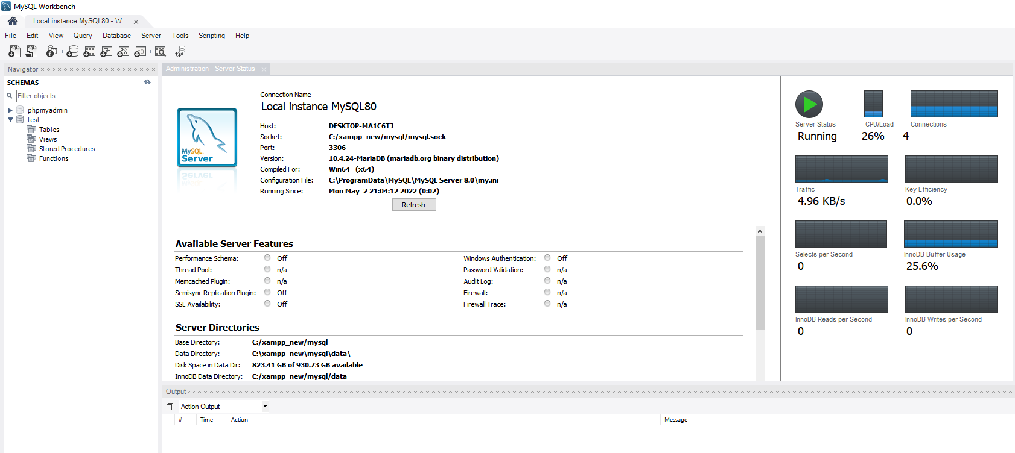Screen shot of MySQL before schema created:

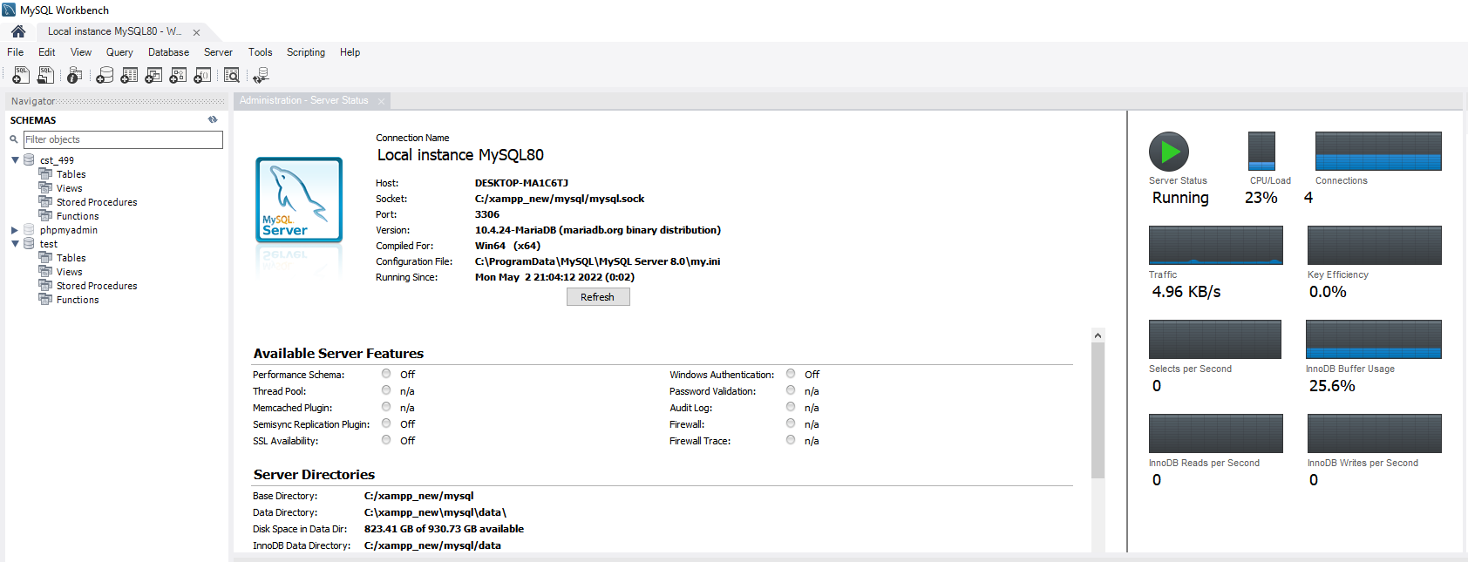Screen shot of MySQL after schema created:

Screen shot of MySQL showing before tables are created:

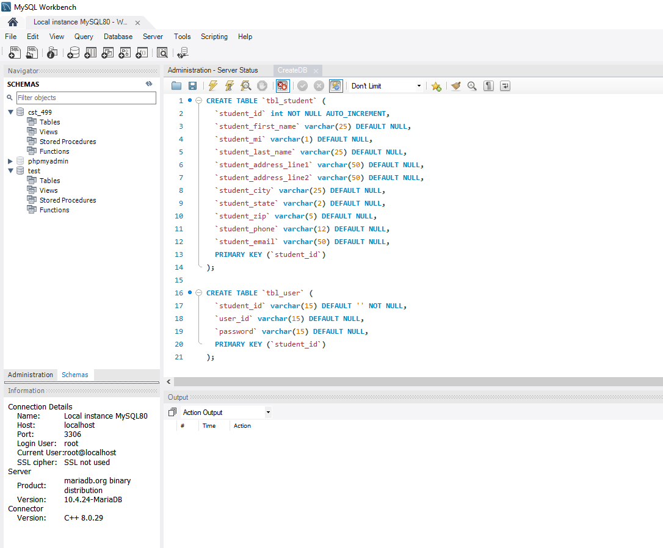

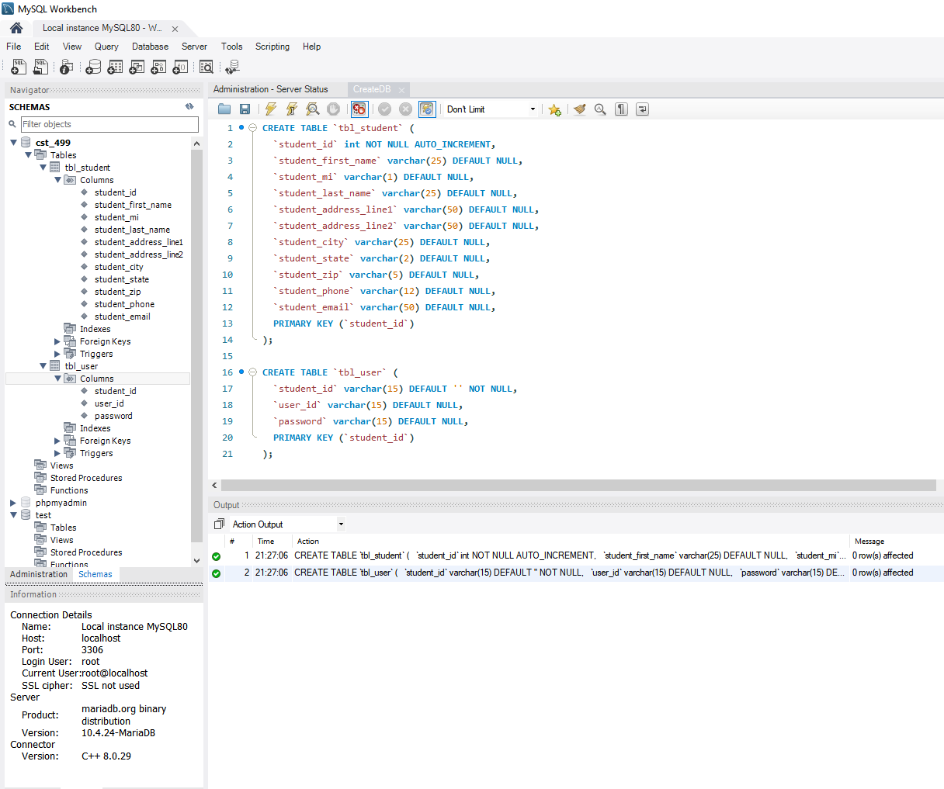Screen shot of MySQL showing before tables are created:

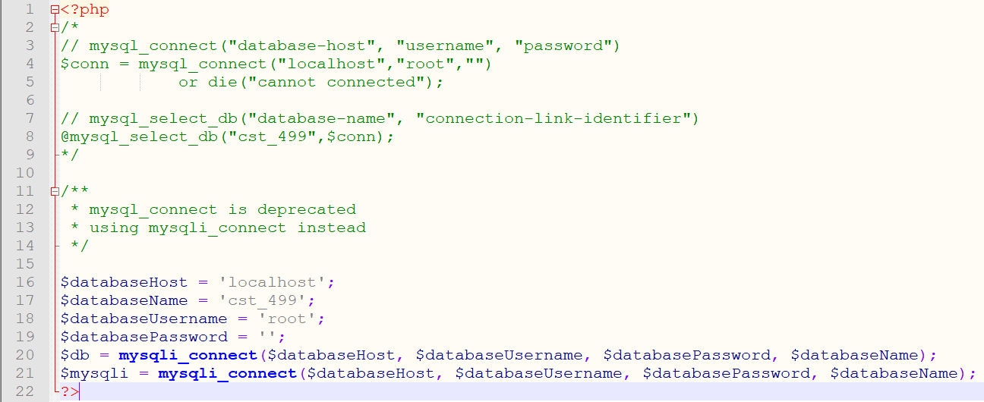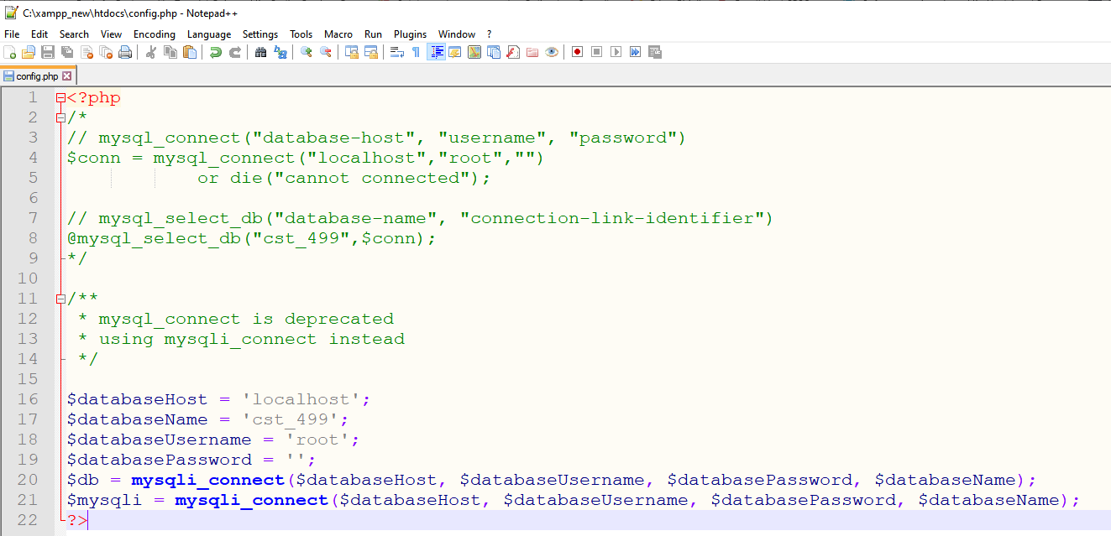Generate screenshots of the PHP code to implement your logic.

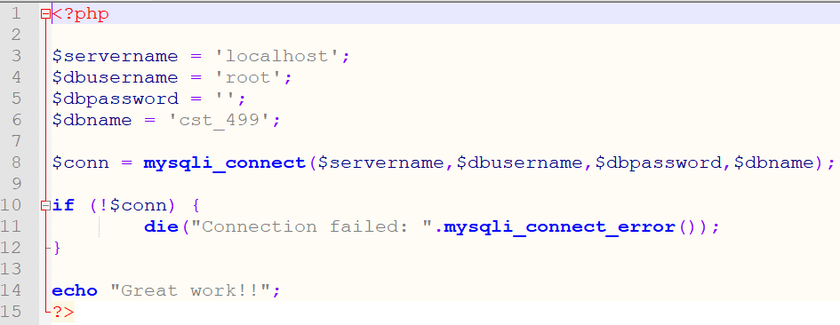

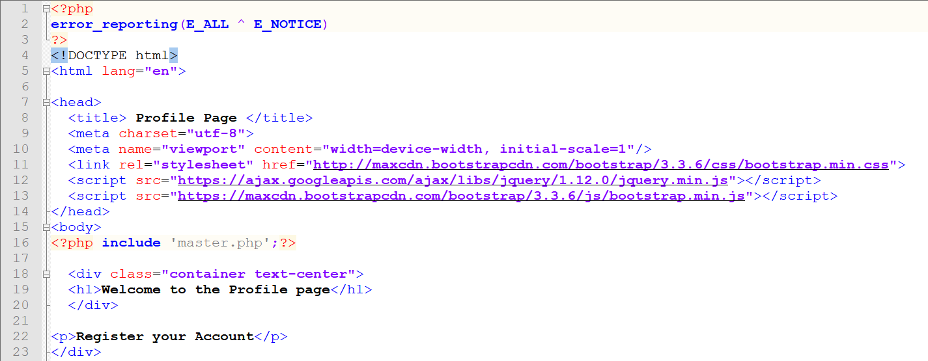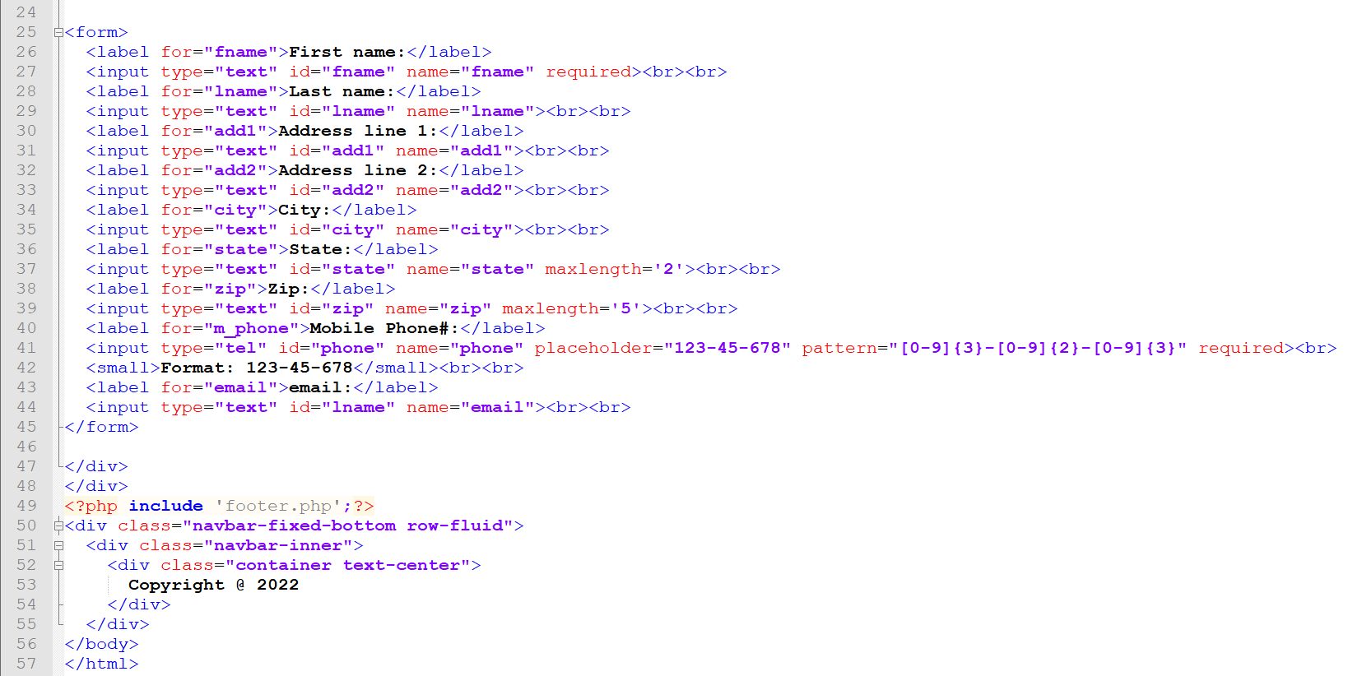

**Summarize your experience going through the implementation phase**

“The ultimate goal of most software engineering projects is to produce a working program”, (Tsui et. al., 2018, p. 192). Honestly, the implementation phase was rough because of not using XAMPP and MySQL Workbench for several months, I forgot where to start. After uninstalling and reinstalling XAMPP multiple times and then re-installing MySQL and watching a few ‘You Tube’ videos, I was able to successfully create a schema and then create the database tables. Using a combination of applications and languages almost anyone can create a client facing web-based application where the owner has control over the layout and the content on the pages and control over how the data is stored, retrieved and used.

**References**

Tsui, F., Karam, O., & Bernal, B. (2018). [Essentials of software engineering](https://ashford.instructure.com/courses/100130/modules/items/5077278)(4th ed.). Jones & Bartlett Learning.